OPERATION AND MAINTENANCE INSTRUCTION MANUAL

MANUAL DOCK RAMP
NAME OF THE CUSTOMER : Ingersoll Rand India Ltd
SL. NO : NMR-180
DATE : 18/05/2015


TABLE OF CONTENTS

- GENERAL INFORMATION
  - Introduction
  - Construction of equipment
  - Technical Specifications
  - General Assembly Drawings
  - Use of the equipment
  - Special features
- OPERATION OF THE EQUIPMENT
  - Sequence of operation
  - Owners Responsibility
- SAFETY
  - Safety Warnings
  - Notice Items
- MAINTENANCE
  - Maintenance Schedule
  - Certificates and Reference
  - Warranty Clause

- GENERAL INFORMATION
  - Introduction
Please read and understand this manual carefully before Installing, starting, operating, repairing or maintaining the Manual Dock Ramp. This equipment is designed by NIHVA TECHNOLOGIES to provide safer place for workers in the shipping and receiving dock areas. The Dock Ramp when properly installed and operated provides safe and secure access between the loading dock and vehicle/truck. The Dock is operated from the operator Screw jack. This manual provides information regarding the installation, use, operation, safety, repair and maintenance of the equipment. The operator and maintenance staff should be trained before using of this equipment. Please contact NIHVA for any further query, clarification or more information required. Preserve this manual in good condition throughout the service life of the Equipment/Machine. The operator and all persons who may come into contact of this equipment should read it regularly and have access to it at all times. Failure to comply with the safety instructions and warnings in this manual may result in serious injury to the operator or other persons in the vicinity of the machine. The equipment is usable within the temperature range from -20°C to 45°C. Authorized personnel are staff who are permitted to operate a Dock Ramp according to local statutory requirements and are appointed within the company to do this.

The equipment is designed with UDL capacity 15000kgs, Platform Size 7000x2750mm, maximum lift 1300mm, Fixed height is 1100mm, & 8 nos. of screw jack to the main platform is required manual operating.
  - Construction of the equipment
The equipment mentioned is constructed with MS structure with optimum design with all the required safety measures. All the pins and rods are hardened. are constructed with MS structure and solid rubber type wheel.

  - Technical Specifications

1. UDL Capacity 15000kgs
- Platform Size 7000x2750mm (L x W)
- Lip Size 2750x350mm
- Overall Length – 8350mm
- Overall Height - 1300mm Approximate
- Fixed Height – 1100mm
- Product Sr. No. NMR-180
- Year Of Manufacturing: May 2015

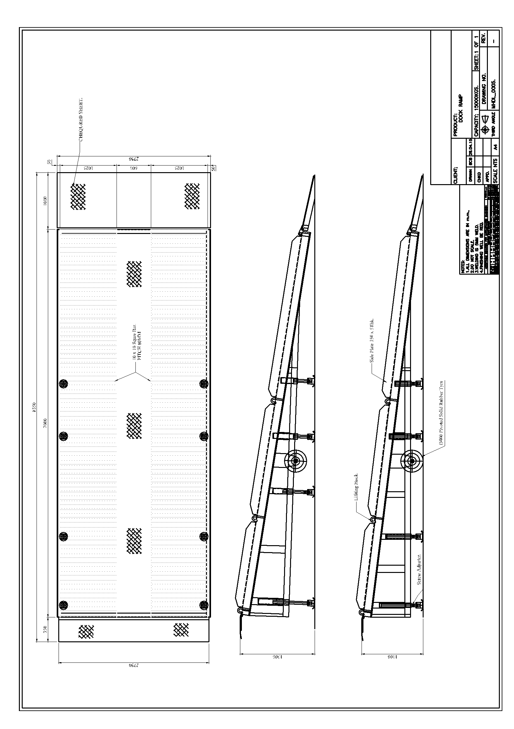
  - General Assembly Drawing

  - Use of the Equipment
Dock Ramp is designed to bridge the height between the loading platform and the height of the vehicle to be loaded or unloaded. One side of the equipment is flushed to the shop floor and another side of the equipment is adjustable with the help screw jack. This equipment enables the forklift operator to drive the forklift/trolley directly into the vehicle so that the loading/unloading operation can be completed smoothly. This helps to improve the efficiency of operators, to reduce the man power, save time and other related valuable resources.

1.6 Special Features

The equipment is designed with Screw jack to lift the Dock ramp and 8 nos floor locks to support the ramp.

- OPERATION OF THE EQUIPMENT
  - Sequence of operation
- Install the equipment where you want to loading and unloading material.
- Set the vehicle in reverse way parallel to the equipment,. Put jammers to the vehicle tyres,. so that it will not move during loading/unloading operation.
- Ensure for any human intervention on the equipment platform, near to the moving parts of the equipment. There should not be any vehicle, trolley standing on the platform while lifting/lowering of the platform.
- Lift the “PLATFORM UP” by using Screw jack to the maximum height. Then lift the “LIP UP” by manually and rest on the vehicle.
- Fix the all floor locks to the ground tightly .
- Complete the loading OR unloading of the material. After completion of loading and unloading remove the floor locks by rotating lever anticlockwise direction.
- After completion of loading OR unloading of the material, loose the lever of pressure and take the platform down. Lift the lip by manually and lock by using chains.
- Remove all the debris around the equipment generated during loading OR unloading operation. Keep the surrounding area of the equipment neat and clean.
  - Owner’s Responsibility
- The owner should recognize an inherent danger of the interface between dock and the transport vehicle. The owner therefore, shall train and instruct the operators in the safe use of the dock equipment in accordance to the information provided below.
- When a transport vehicle is parked at a loading dock, it is important that the vehicle is relatively perpendicular to the dock face and in close contact with the dock bumpers.
- Nameplates, cautions, instructions, and posted warnings shall not be obscured from the view of operating or maintenance personnel for whom such warnings are intended.
- Manufacturer’s recommended periodic maintenance and inspection procedures in effect at date of shipment shall be followed, and written records of the performance of these procedures should be kept.
- Dock equipment that is structurally damaged shall be removed from service, inspected by a manufacturer’s authorized representative, and repaired as needed before being placed back in use.
- The manufacturer shall make available replacement nameplates, caution/instruction labels, and operating/maintenance manuals upon request of the owner. The owner shall see that all nameplates, caution/instruction markings or labels are in place and legible, and that the appropriate operating/maintenance manuals are provided to users.
- Modifications or alterations of dock equipment shall be made only with written permission of the original manufacturer. These changes shall also satisfy all safety recommendations of the original equipment manufacturer for the particular application of the dock equipment.
- In order to be entitled to the benefits of the standard product warranty, the dock equipment must have been properly installed, maintained and operated within its rated capacities and/or specific design parameters, and not otherwise abused.
- It is recommended that trailers equipped with air ride suspensions should remove the air from the suspension to minimize trailer bed drop, prior to loading or unloading.
- When industrial trucks are driven on and off transport vehicles during the loading and unloading operation, the brakes on the transport vehicle shall be applied and wheel chocks or a positive restraining device shall be engaged.
- In selecting dock equipment, it is important to consider not only present requirements but also future plans or adverse environments.

- SAFETY
While working with the Dock Ramp, the person who is responsible for supervising the operation environment should take the necessary organizational measures to guarantee the employees' health and safety as required by local legislation. The operator or supervisor

3.2 Notice Items
1. Read the manual book carefully before using the equipment, to know the performance and use of the equipment. Only authorized operators are allowed to use the equipment.
2. Do not overload, use within the rated load, overload will damage to the equipment, people and goods;
3. The screw jack system only plays the role of lifting the platform of Dock ramp and connecting to the truck. Please note it does not function to lift the heavy load. It is forbidden to put the heavy goods on the dock platform to lift, in order to prevent the damage of the hydraulic system and Dock Ramp.
5. Please use the mechanical stoppers whenever you need to carry out any repair and maintenance work under the platform of the dock Ramp. This will prevent the falling of the dock platform and ensure the safety during repair and maintenance.
6. Strictly operate according to the “Notice items”, otherwise it will cause damage to the people and vehicles and goods.

- MAINTENANCE
4.1. Maintenance Schedule
Daily Maintenance
- Remove debris and other un-necessary material around the Dock ramp, keep the area around neat & clean. Be sure the hinge section of the Dock Ramp lip and the platform is clean.
- Clean the Dock Ramp for any dirt, dust etc.
- Check unit for proper operation.

90 Days
- Perform all Daily Maintenance.
- Lubricate the unit with the proper lubricants.
- Inspect structure, hinge pins, cotter pins for abnormal wear.
- With the leveler supported by the mechanical stopper, check hydraulic fluid level in tank. Add fluid if necessary.
- Check conditions of concrete, floor lock mounting floor variation.

4.2 Certificates and References
The following certificates are attached in annexure at the end of this manual for the future reference of the buyer;
- Warranty Certificate

4.3 Warranty Clause
We certify that product(s) mentioned and supply as above meets our standard design and specification shown in our catalogue(s) and/or quotation(s) and/or specification sheet(s) unless otherwise specifically agreed by us. We warrant that the product(s) is free from defects in workmanship and material. This warranty does not cover damage resulting out of incorrect use or improper handling. We are not liable for consequential damages.
*****#####*****

